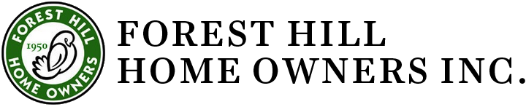
Combined Executive Committee and Board

Date: September 14, 2022, 7 pm
Blue Cottage 2419 Lee Blvd. Cleveland Hts, OH
Present: Gretchen Mettler, Ko Carten, Fran Mentch, Beryl Tishkoff, Tony Rupcic, Chris Hubbert (for half of meeting), Jan Milic, Tracey Kirksey
Excused: Jim Havach,
Absent: Mary Rice, Lee Barbee, Jackie Kelly, Nate Wright, Donna Kolb.
Jammie Artise has resigned as a trustee.

Agenda
- Call to order. Meeting called to order by Gretchen at 7p.m.
- August 10, 2022, Meeting Minutes were approved.
- Treasurer’s Report- Tony reported that as of August, we have not received sufficient dues or donations to pay for our current expenses. We are about $2100 short as of now. Based on past years though, we expect to have sufficient funding by years end.
Tony has set up separate accounting for the funds that are pledged and donated for the Blue Cottage Restoration.
- Bylaws Committee Chris led a discussion of the 9-02-22 draft of the FHHO By-Laws. Article III. Sections 3.1 through 3.5 were reviewed, revised, and approved. The revisions will be submitted to membership at the Annual Meeting.
- Blue Cottage restoration report – Beryl reported that there are $1400 in pledges thus far. A resident contacted TV Channel 5 reporter, Jessi Schultz, who did a report about the Blue Cottage Restoration. She interviewed Beryl and Tony and Gretchen on 9/14/22. The video will be aired in a few days and can be seen on the channel 5 web site, online at this link: https://www.news5cleveland.com/news/local-news/oh-cuyahoga/forest-hills-community-fundraising-to-save-a-small-cottage-with-big-ties-to-clevelands-history Tony will contact the National Trust for Historic Preservation about funding sources. The Blue Cottage Fundraising committee met and planned to contact various sources for funding.
- Planning for the Annual Meeting
Gretchen asked the board to nominate neighbors for awards for preservation and appearance and improvements to homes.
Annual Meeting will be held on November 16th at 7p.m. at Forest Hill Church. We discussed possibility for refreshments.
We’ll need to discuss AV equipment with the church.
- New Business- the only referral to the Standards Committee was made by John Walls, the new owner of 503 Burlington Rd. He has applied to FHHO and received approval to install black muntin bars on the windows. He is also working with Cleveland Heights’ Architectural Board of Review.

Meeting was adjourned at 8:20p.m.
Submitted by Fran Mentch, Secretary.

