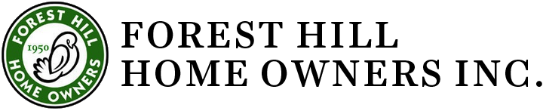
Combined Executive Committee and Board

October 12, 2022 7 pm
Blue Cottage 2419 Lee Blvd. Cleveland Hts, OH
Present: Gretchen Mettler; Tony Rupcic, Tracey Kirksey, Jan Milic, Beryl Tishkoff; Fran Mentch, Jim Havach, Ko Carten.
Excused: Chris Hubbert
Absent: Jackie Kelly, Nate Wright, Mary Rice, Donna Kolb Jones, Lee Barbee

Agenda
- Call to order by Gretchen at 7:05.
- September 12, 2022 Meeting Minutes were approved.
- Treasurer’s Report-Tony presented the financial report, current as of 9/30/22. Donations and dues for this year are lower than last year. He recommends that an email should be sent to those who gave last year but have not done so this year. There was some discussion about the possible sale of the Burlington lot, but no decision made.
- Bylaws Committee-Chris was unable to attend but emailed information and draft by-laws prior to the meeting. The draft revisions were accepted and will be presented to membership at the Annual Meeting for approval.
- Nominating Committee – Jim is working on the slate of trustees to be presented to members at the Annual Meeting. There was a discussion about who else can be approached about becoming a trustee; there is a need to have young people, new residents and people from all neighborhoods represented on the Board. The trustee application is on the FHHO website. Current Board members who are interested in continuing must reapply.
- Standards – Tony reported a September roof approval. Slate roof removal exception is granted because the existing slate roof was quarried in the Pennsylvania Lehigh region. That particular slate has 50-year life span. We determined and verified that the slate roof is not restorable. The slate has softened overtime and it is disintegrating. Fortunately, most of the slate roofs in Forest Hill were quarried in Vermont. Those roofs have 125 to 200 year and beyond life span and are highly restorable. Grand Manor® was selected as the replacement. That particular product visually mimic’s slate and conforms to our guidelines. A Burlington window approval was sent on 9/15. Only after he already ordered the windows and scheduled the installation. I was fine with it after I Googled white colonial home with black muntins. There are many nice examples.
- Blue Cottage Restoration report – Beryl reports we need more committee members to work on the Restoration. So far there are 22 donors who have pledged $7,290. A Go-Fund Me webpage may be set up soon to increase accessibility for donors and to provide some publicity. There was discussion about FHHO making a donation; a final decision about this will be made towards the end of the fundraising campaign. Board members were encouraged to donate to the Restoration fund.
- Slate/tile roof survey, letter – Jan and Ko have been conducting an inventory of homes with slate, tile, shakes. Purpose of the inventory is for FHHO to follow-up with these homeowners and explain the need for them to contact FHHO Standards and the city Architectural Review Board prior to finalizing plans with a roofing company. And to provide them with technical and financial resources to help with repair of these roofs. Discussion about how best to do this resulted in a decision to invite Cleveland Heights city staff to meet with the FHHO Board and Executive Committee to determine how the City and FHHO can work most effectively together on maintaining these standards.

The Meeting adjourned at 8:30 p.m.
Respectfully submitted,

Fran Mentch

